Scaler - Coffee Chain DataAnalysis Report

1. **Introduction.**

CCD is losing money and Data is provided to pinpoint the trends, patterns to find why they are losing the money.

1. **Objective.**

Transform Raw data into Rich Visual insights to help stakeholders with a clear view of their sales data allowing them to make Data driven decisions that can boost Profitability and Efficiency.

1. **Data.**

Dataset has 2 tables, Coffee Chain and Product Types.

Coffee Chain table contains information about the Coffee chain product, Sales, State, and the subsequent data.

Product types table contains information of Product type.

1. **KPI’s and Problem Statements.**

This data analysis is focused around the reasons for the Losses by the Coffee chain, hence the Key Performance Indicators(KPIs) are -

1. Market-wise Percentage contribution to Total Sales
2. Product types with Percentage contribution to Total Sales
3. Store id with highest sales value
4. Store id with highest total expense
5. Profit Margin for year 2012 and 2013
6. COGS of various products in 2012 & 2013.
7. Cost of Marketing for various market sizes.
8. State-wise Sales in Major & Minor markets.
9. **Visualization.**

Graphs, Charts, Pivot tables are added to address KPI’s. Dynamic filters & Slicers to explore Data help in interactivity.

After data cleaning and processing, answers to the most important questions and problem statements are found to help the client understand how the sales have performed across time, products and other parameters.

Given below are the important KPI’s and its solutions listed in the form of Graphs, Charts, and tables.

1. Percentage contribution of each market to Total Sales.

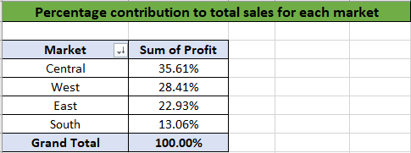

1. Product types with Percentage contribution to Total Profit.

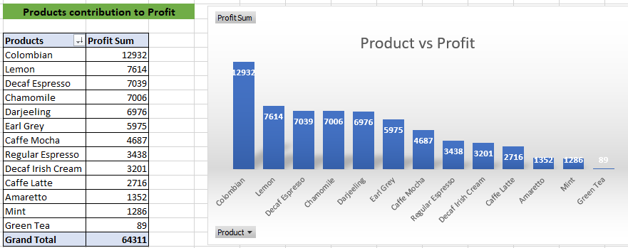

1. Product types with Percentage contribution to Total Sales in 2012.

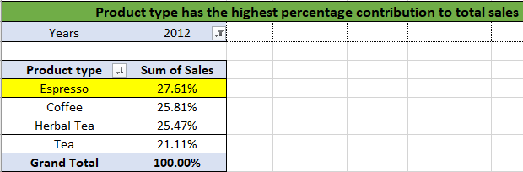

1. Store id with highest sales value.

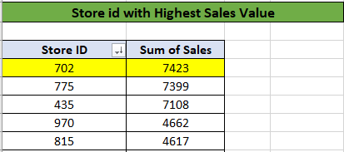

1. Profit Margin for year 2012 and 2013.

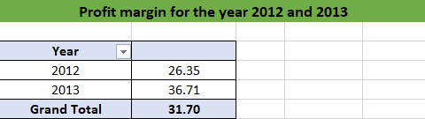

1. Store id with highest total expense.

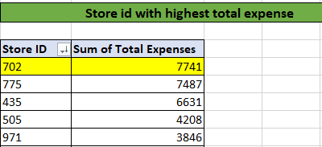

1. Cost of Marketing for various market sizes.

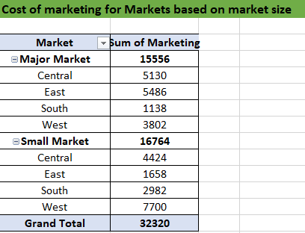

1. State-wise Sales in Major & Minor markets.

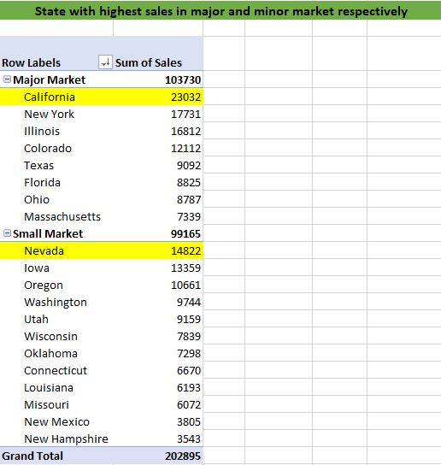

1. **Insights and Recommendations.**
2. Profitable products have no sales in certain markets. Ex. Chamomile sales in East market.

Ex. Darjeeling sales in South market.

Improving Sales of profitable products in the markets where currently it is negligible.

1. 63% (94) stores have Sales less then $1300 which is the average sales for all stores. Majority of Sales and Profit comes from selected stores .

Efforts to improve the sales and profits of Stores where the Sales is below $500.

1. Sales on 1st Oct is high compared to 1st Nov in 2012 and 2013. Sales are highest on 1st Dec. 2012 and 2013.